# 

# **DEBRE TABOR UNIVERSITY**

# **FACULTY OF TECHNOLOGY**

# **DEPARTMENT OF COMPUTER SCIENCE**

# 

# **Title: - Patient tracking system**

# **Prepared by: Section 1 group 5 students**

# **Name ID No**

# **Abdulsomed Jibri DTU13R0024**

# **Betelhem G/Mehdin DTU13R0289**

# **Dawud Worku DTU13R0466**

# **Timket Getachew DTU13R1652**

# **Emran Ahmed DTU13R0584**

# **Muluken Dagne DTU12R1094**

# **Yitbarek Maru DTU13R1818**

# **Samuel Kasahun DTU13R1450**

# 

# **Debre Tabor, Amhara, Ethiopia June 2023**

# **Abstract**

The proposed patient tracking system is a cutting-edge solution designed to streamline and enhance patient management in healthcare facilities. With its user-friendly interface and advanced features, the system aims to improve the efficiency, accuracy, and overall quality of healthcare delivery.

The manual patient tracking system relies on paper-based records and manual processes for managing patient information, appointments, and medical history. It involves maintaining physical files, scheduling appointments through phone calls or in-person visits, and manually updating patient records. This traditional approach can be time-consuming, prone to errors, and lacks efficient data management and accessibility.

For our project, we propose to digitize the patient tracking system to overcome these limitations. The digital system will automate the process of recording patient information, scheduling appointments, and maintaining up-to-date medical records. It will provide a user-friendly interface for healthcare professionals to input and access patient data efficiently. The proposed system aims to improve the overall efficiency, accuracy, and accessibility of patient tracking, enhancing the quality of healthcare services.

# Acknowledgment

A patient tracking system plays a crucial role in healthcare facilities by providing accurate and efficient tracking of patient information throughout the healthcare journey. From appointment scheduling to discharge, a patient tracking system allows for better communication between healthcare providers, reduces wait times, and ultimately improves patient outcomes. It allows healthcare providers to access vital patient information in real-time, facilitating timely decision-making and treatment. The system also improves data management, reduces errors, and streamlines administrative tasks. A patient tracking system is a valuable tool that enhances the quality of care delivered to patients while also improving the overall efficiency and effectiveness of healthcare services.

**Abstract 1**

**Acknowledgment 1**

**Chapter 1: Introduction 3**

**1.1 Introduction 3**

1.2 Statement of the problem 3

1.3 The objective of the project 4

1.3.1 General objective 4

1.3.2 Specific objective 4

1.4 Feasibility analysis 5

1.4.1 Operational feasibility 5

1.4.2 Technical feasibility 5

1.4.3 Economic feasibility 6

1.5 Scope of the project 6

1.6 Limitations of the project 6

1.7 Significance of the project 7

1.9.1 Fact-finding techniques 8

1.10 System analysis and Design approach 9

1.11 Development tools 10

1.11.1 Software requirements 10

1.12 Testing procedures 10

1.12.1 Unit testing 10

1.12.2 Integration testing 11

1.13 Risks and contingencies 12

**Chapter 2: Description of the existing system 12**

2.1 Introduction of the existing system 12

2.2 Major functions/activities in the existing system 13

2.3 Players in the existing system 14

2.4 Business Rules 15

2.5 Bottlenecks of the existing system 16

2.6 Proposed solution to address problems of the existing system 17

2.7 Requirements of the proposed system 18

2.7.1 Functional requirements 18

2.7.2 Non-functional requirement 19

**Chapter 3: System analysis 21**

3.1 System models 21

3.1.1 Actors and use case identification 21

Actors 21

Use cases

3.1.2 Use case diagram

3.1.3 use case description

3.1.4 object model

22

# 

# **Chapter 1: Introduction**

# 1.1 Introduction

The proposed patient tracking system is a new and innovative solution designed to enhance the efficiency and accuracy of patient management in healthcare facilities. This project aims to leverage modern technologies and streamlined processes to improve the overall patient experience and optimize healthcare delivery.

By implementing this patient tracking system, healthcare providers will have a comprehensive tool at their disposal to track and monitor patient information, appointments, treatments, and medical history. The system will enable seamless coordination and communication between various healthcare professionals, ensuring that patients receive timely and appropriate care.

This proposed project introduces a user-friendly interface that simplifies data entry, retrieval, and analysis, allowing healthcare providers to access real-time patient information at their fingertips. With automated appointment scheduling, electronic medical records management, and streamlined billing processes, the system will significantly reduce administrative burdens and minimize errors.

Furthermore, the proposed patient tracking system will prioritize data security and confidentiality, adhering to industry standards and regulations to safeguard sensitive patient information. It will also provide customizable reporting and analytics capabilities, empowering healthcare administrators to make data-driven decisions and optimize resource allocation.

Overall, the proposed patient tracking system represents a transformative step in healthcare management, fostering improved patient outcomes, increased operational efficiency, and enhanced collaboration among healthcare professionals.

## 1.2 Statement of the problem

From the perspective of healthcare facilities, the existing patient management processes present several challenges that hinder operational efficiency and patient care. Manual record-keeping and communication methods lead to delays, errors, and potential misinterpretation of patient information. The lack of a centralized system makes it difficult to track patient appointments, monitor treatment progress, and access medical history in a timely manner.

Without a comprehensive patient tracking system in place, healthcare providers face difficulties in coordinating care among different departments and healthcare professionals. The absence of real-time data availability makes it challenging to make informed decisions regarding patient care, resulting in potential delays and suboptimal treatment outcomes. Additionally, the manual nature of administrative tasks, such as appointment scheduling and billing, consumes valuable time and resources that could be better utilized for patient care.

The absence of a standardized and integrated system also poses data security and confidentiality risks. Paper-based records are susceptible to loss, damage, or unauthorized access, compromising patient privacy and confidentiality. Healthcare facilities need a solution that ensures data security, adheres to regulatory standards, and provides traceability and accountability in accessing and managing patient information.

Overall, the lack of an efficient patient tracking system creates a disjointed patient experience, increases administrative burdens, hampers effective communication and collaboration among healthcare professionals, and hinders the overall quality of care provided. Implementing a robust and innovative patient tracking system addresses these challenges and paves the way for improved patient management, enhanced operational efficiency, and better healthcare outcomes.

## 1.3 The objective of the project

### 1.3.1 General objective

The main objective is to develop a patient tracking system.

### 1.3.2 Specific objective

* Improve patient experience: Enhance the overall experience for patients by providing streamlined appointment scheduling, reduced waiting times, and improved access to their medical records.
* Enhance operational efficiency: Streamline administrative tasks such as patient registration, billing, and documentation, reducing manual errors and improving efficiency in healthcare operations.
* Increase accuracy and quality of care: Enable healthcare professionals to access up-to-date patient information, including medical history, allergies, and medication records, to facilitate accurate diagnosis and treatment decisions.
* Facilitate effective communication and collaboration: Enable seamless communication and collaboration among healthcare teams, ensuring timely exchange of patient information and promoting coordinated care.
* Enhance data security and privacy: Implement robust security measures to protect patient data, ensuring compliance with privacy regulations and safeguarding sensitive medical information.
* Generate comprehensive reports and analytics: Provide comprehensive reporting and analytics capabilities to healthcare administrators, enabling data-driven decision-making and performance monitoring.
* Optimize resource allocation: Improve resource allocation by analyzing patient flow, identifying bottlenecks, and optimizing staff and equipment utilization to improve operational efficiency.
* Support interoperability: Enable integration with existing healthcare systems and external stakeholders, facilitating seamless data exchange and interoperability between different healthcare providers.
* Increase accessibility and convenience: Offer online access to patient information, appointment scheduling, and telehealth services, improving accessibility and convenience for patients.
* Foster continuous improvement: Support continuous quality improvement initiatives through data analysis, feedback mechanisms, and performance monitoring, aiming to enhance patient care and operational effectiveness over time.

## 1.4 Feasibility analysis

The objective of a software feasibility study, as the name implies, is to assess from the operational, technical, economic, and organizational points of view whether the project is viable. It assesses the viability of the project idea from different perspectives.

### 1.4.1 Operational feasibility

The proposed patient tracking system exhibits strong operational feasibility. It focuses on providing an easy-to-use, reliable, and secure service for healthcare providers and staff involved in patient tracking. The system is designed with simplicity in mind, ensuring that users can quickly navigate and utilize its features without requiring any additional or specialized skills. It operates neutrally, safeguarding against scams and abnormal transaction manipulations.

Daily operations can be efficiently managed with minimal staff, encompassing tasks such as transaction control, user authentication, and system administration. The system also demonstrates scalability, with sufficient capacity to accommodate future needs, such as partnerships with banking institutions for credit facilities and the ability to recommend investments and products to target users.

Furthermore, it creates opportunities for advertisers and producers to showcase their content and products, contributing to a comprehensive and value-added user experience. Overall, the proposed patient tracking system offers an effective and feasible solution for healthcare organizations seeking improved patient tracking capabilities.

### 1.4.2 Technical feasibility

Our patient tracking system demonstrates strong technical feasibility. The analysis of existing technology indicates that the system can be developed using current tools and frameworks. We have planned to utilize modern technologies such as React, Node.js, and MongoDB for developing and designing different components of the system. These technologies are widely accessible and open-source, providing us with viable options for development.

Furthermore, our team possesses the necessary skill sets and expertise to develop the proposed system in-house. With the available experts and their proficiency in the chosen technologies, we are well-equipped to handle the development process efficiently.

In terms of hardware and software requirements, our current infrastructure is capable of supporting the system during the development and testing phases. Even during the deployment and launch stages, there are numerous alternatives available to ensure we have sufficient storage and processing power.

Overall, based on the accessibility of appropriate technologies, the availability of skilled personnel, and the adequacy of our hardware and software components, our patient tracking system is technically feasible.

### 1.4.3 Economic feasibility

The patient tracking system proposed is economically feasible as it leverages free and open-source tools, eliminating the need for significant upfront investments. With its focus on financial transactions, the system has a high income potential, ensuring profitability and covering operational costs. Furthermore, digitizing manual processes reduces time and cost inefficiencies, benefiting both healthcare providers and patients. Overall, the system offers tangible benefits such as cost savings, improved reliability, and a culture of digital savings, making it economically advantageous for healthcare organizations.

## 1.5 Scope of the project

The scope of the proposed project is to digitize and automate the patient tracking system, providing a comprehensive and efficient solution for managing patient records, appointments, medical history, and other relevant information. The system will encompass functionalities such as patient registration, scheduling, record management, billing, and reporting, ensuring improved accuracy, accessibility, and overall efficiency in healthcare operations.

## 1.6 Limitations of the project

One limitation of the proposed patient tracking system is the potential challenge in integrating the system with existing external systems, such as electronic health records (EHRs) or other healthcare information systems. This could arise due to compatibility issues, varying data formats, or limitations in data sharing protocols. The seamless exchange of patient information between different systems is crucial for effective care coordination and continuity. Overcoming this limitation will require careful planning, collaboration with external system providers, and the development of robust data integration strategies to ensure the smooth flow of information.

## 1.7 Significance of the project

The proposed patient tracking system significantly improves healthcare delivery through streamlined management of patient information, enhanced care coordination, and improved patient safety. It automates processes, reduces paperwork, and enables seamless communication among healthcare providers, resulting in efficient workflow and optimized patient care. With accurate and accessible patient data, the system reduces errors and facilitates evidence-based decision-making. Overall, it revolutionizes patient management, leading to better healthcare outcomes and a more streamlined and patient-centric approach.

## 1.8 The target beneficiaries of the system

The target beneficiaries of the proposed patient tracking system include:

**1. Healthcare Providers**: The system empowers healthcare professionals by providing them with easy access to comprehensive patient information, facilitating efficient care delivery, and improving decision-making.

**2. Patients:** The system benefits patients by ensuring accurate and up-to-date medical records, enabling better coordination of care across different healthcare providers, and empowering them to actively participate in their own healthcare management.

**3. Caregivers:** Family members or caregivers responsible for a patient's well-being can benefit from the system by having access to real-time patient information, facilitating better communication with healthcare providers, and ensuring coordinated care.

**4. Healthcare Institutions:** The system helps hospitals, clinics, and healthcare facilities improve operational efficiency, reduce administrative burdens, and enhance patient safety. It aids in better resource management, optimizing patient flow, and ensuring compliance with regulatory standards.

**5. Researchers and Public Health Organizations:** The system provides valuable data for research purposes, allowing researchers and public health organizations to analyze trends, patterns, and outcomes, leading to advancements in medical knowledge and improved public health initiatives.

## 1.9 The methodology for the project

## The methodology for the patient tracking system project includes the following steps:

**1. Requirements Gathering:** Collecting and documenting the specific needs and requirements of the system from stakeholders, such as healthcare providers, patients, and administrators.

**2. System Design:** Creating a high-level system design that outlines the architecture, modules, and functionalities of the patient tracking system.

**3. Technology Selection:** Choosing the appropriate technologies and tools to develop the system, considering factors such as scalability, security, and integration capabilities.

**4. Development:** Implementing the system based on the design, including developing the user interface, database structure, and backend functionality.

**5. Testing:** Conducting comprehensive testing to ensure the system functions correctly, including unit testing, integration testing, and user acceptance testing.

**6. Deployment:** Deploying the patient tracking system in a production environment, configuring servers, setting up security measures, and ensuring system availability.

**7. Training and User Adoption:** Providing training and support to healthcare providers, administrators, and other users to ensure a smooth transition and effective utilization of the system.

**8. Maintenance and Upgrades:** Continuously monitoring and maintaining the system, addressing any issues or bugs that arise, and periodically upgrading the system to incorporate new features or address evolving needs.

The methodology ensures a structured approach to the development and implementation of the patient tracking system, enabling effective requirement gathering, efficient development, and successful deployment while considering the needs of stakeholders and maintaining system functionality and reliability.

### 1.9.1 Fact-finding techniques

The fact-finding techniques used for the patient tracking system project include:

**1. Interviews:** Conducting structured interviews with stakeholders, such as healthcare providers, administrators, and system users, to gather information about their requirements, workflows, and challenges.

**2. Observation:** Observing the current processes and workflows in healthcare facilities to understand how patient tracking is currently handled, identify bottlenecks, and gather insights for system improvement.

**3. Document Analysis:** Reviewing existing documents, such as medical records, patient forms, and operational procedures, to extract relevant information and understand the data and documentation requirements for the patient tracking system.

**4. Surveys:** Administering surveys to collect feedback and opinions from healthcare professionals, patients, and other system users to gather quantitative and qualitative data about their experiences, preferences, and needs.

**5. Prototyping:** Creating interactive prototypes or mockups of the patient tracking system to gather feedback from stakeholders, validate requirements, and refine the system design.

These fact-finding techniques provide valuable insights into the current state of patient tracking, user needs, and system requirements. By combining interviews, observation, document analysis, surveys, and prototyping, the project team can gather comprehensive information to inform the design and development of an effective patient tracking system.

## 1.10 System analysis and Design approach

The system analysis and design approach for the proposed patient tracking system includes the following steps:

**1. Requirements Gathering:** Collecting specific requirements through interviews, observations, and document analysis.

**2. System Modeling:** Creating visual models and diagrams to depict system components and data flows.

**3. System Architecture:** Defining the hardware, software, and network infrastructure of the system.

**4. Database Design:** Designing the structure and schema of the database to store patient data.

**5. User Interface Design:** Designing an intuitive and user-friendly interface for the system.

**6. System Development:** Implementing the system using appropriate programming languages and frameworks.

**7. Testing and Quality Assurance:** Conducting thorough testing to ensure system functionality and reliability.

**8. Deployment and Maintenance:** Deploying the system and providing ongoing support and updates.

This approach ensures a systematic and efficient development process for the patient tracking system, meeting the requirements of healthcare providers and administrators while delivering a user-friendly solution for patient management.

## **1.11 Development tools**

### 1.11.1 Software requirements

For the development of this project, the following software requirements have been considered.

* Operating System: Windows 10
* Backend Development Language: Node.Js to create the back-end logic of our system
* Front end Development Language: HTML/CSS/JavaScript (jquery Libraries)
* UI Framework: React
* Design: Adobe Illustrator for designing the graphics interface of the app
* Code Editor: Visual studio code for typing the application scripts
* Debugger Chrome browser's developer's tool kit
* Documentation Tools: Google Docs and WPS office
* Powerpoint Slides Tools: google slides
* Drawing Tools: Wondershare EdrawMax

### 1.11.2 Hardware requirements

* Computer Device: Laptop or Desktop
* RAM: 8 GB
* Space on Disk: 1 TB hard disk
* Versatile Disk: Flash drive (32Gb)
* Paper: A4 size paper
* Writing tools: Pen and pencil

### 

## 1.12 Testing procedures

We will implement a set of steps used to ensure that the software product that we will deliver works as expected.

### 1.12.1 Unit testing

Unit tests are automated and can be run quickly; they check individual units of code (such as functions) to make sure they are working correctly

User Input Field Testing: Test all user input fields for accuracy, security, and functionality. Validate required fields, character limits, and input masks.

**Database Integration Testing:** Verify the correctness and accuracy of stored information. Check foreign keys, constraints, and data integrity rules.

**Security Testing:** Verify user authentication methods, access privileges, and password protection measures. Ensure appropriate access controls are in place.

**Performance Testing:** Test system response times under heavy loads and concurrent user access. Evaluate page loading speeds, query responses, and data handling capabilities.

These testing methods ensure the accuracy, security, and performance of the proposed patient tracking system, providing a reliable and efficient solution for managing patient information and tracking their progress.

### 1.12.2 Integration testing

Integration Testing of the Patient Tracking System:

* **System Integration Testing:** Verify the proper functioning of all system components, including third-party APIs and databases. Identify and address any issues arising from component interactions.
* **Database Integration Testing:** Ensure accurate data transfer between the application and database. Identify and address discrepancies to maintain data integrity.
* **API Integration Testing:** Assess the integration of external API components with the patient tracking system. Evaluate functionalities, response time, and error handling to meet business requirements.
* **User Interface/Experience (UX) Testing:** Test the consistency of the user experience across web browsers and system interfaces. Analyze logical structure, navigation flow, and readability on different devices for optimal user experience.

These integration testing methods ensure the seamless integration and functionality of the patient tracking system, providing a reliable and user-friendly experience for healthcare professionals and patients.

## 1.13 Risks and contingencies

Risks and Contingencies of the Patient Tracking System:

* **Data Security Risks:** Mitigate the risk of unauthorized access, data breaches, and privacy violations by implementing robust security measures such as encryption, access controls, and regular security audits.
* **Technical Risks:** Address potential technical issues, system failures, and software glitches through thorough testing, continuous monitoring, and prompt bug fixes or system updates.
* **User Adoption Risks:** Ensure effective user training, clear documentation, and user-friendly interfaces to encourage user adoption and minimize resistance to change.
* **Integration Risks:** Plan and test the integration of the patient tracking system with existing healthcare systems, ensuring seamless data exchange and avoiding disruption to critical workflows.
* **Regulatory Compliance Risks:** Stay updated with relevant healthcare regulations and standards to ensure compliance and mitigate any legal or regulatory risks.

**Contingencies:**

* Establish a dedicated response team to promptly address any security breaches or technical issues, implementing contingency plans to minimize downtime and data loss.
* Provide ongoing user training and support to address any user adoption challenges and encourage effective utilization of the patient tracking system.
* Maintain open communication with healthcare stakeholders and IT teams to address any integration challenges and ensure a smooth transition from existing systems.
* Regularly review and update the system to comply with changing regulatory requirements, working closely with legal and compliance experts to mitigate compliance risks.

# **Chapter 2: Description of the existing system**

## 2.1 Introduction of the existing system

The existing patient tracking system is a healthcare software solution designed to manage and monitor patient information, appointments, and medical records. It provides healthcare providers with a centralized platform to track patient demographics, medical history, treatment plans, and diagnostic results. The system aims to streamline administrative processes, improve patient care coordination, and enhance overall efficiency in healthcare settings. By automating various tasks and facilitating data accessibility, the existing patient tracking system helps healthcare professionals in delivering timely and effective care to patients.

## 2.2 Major functions/activities in the existing system

**1. Patient Registration:** The existing system allows healthcare providers to register new patients by capturing their demographic information, contact details, and relevant medical history. This helps in creating a comprehensive patient profile within the system.

**2. Appointment Scheduling:** Healthcare staff can schedule and manage patient appointments efficiently using the existing system. They can check the availability of doctors, assign time slots, and notify patients about their appointment details. This function ensures smooth coordination between patients and healthcare providers.

**3. Medical Records Management:** The existing system facilitates the storage and retrieval of patient medical records. It allows healthcare professionals to document and access patient diagnoses, treatments, prescriptions, and lab results. This function ensures that critical patient information is easily accessible for healthcare decision-making.

**4. Billing and Insurance:** The existing system enables healthcare providers to manage billing and insurance information. It automates the process of generating invoices, tracking payments, and managing insurance claims. This function ensures accurate and timely financial transactions between patients, healthcare providers, and insurance companies.

**5. Patient Communication:** The existing system facilitates communication between healthcare providers and patients. It may include features such as sending appointment reminders, sharing test results, and allowing patients to communicate with their healthcare team through secure messaging. This function improves patient engagement and enhances the overall patient experience.

**6. Reporting and Analytics:** The existing system provides tools for generating reports and analyzing data related to patient demographics, clinic performance, and healthcare outcomes. This function helps in monitoring key performance indicators, identifying trends, and making data-driven decisions to improve the quality of patient care.

**7. Integration with Other Systems:** The existing system may integrate with other healthcare systems, such as electronic health records (EHRs), laboratory information systems, and pharmacy systems. This integration ensures seamless exchange of patient information and promotes interoperability between different healthcare stakeholders.

**8. Security and Privacy:** The existing system incorporates security measures to protect patient data from unauthorized access or breaches. It includes features such as user authentication, role-based access control, and encryption of sensitive information. This function ensures the confidentiality and privacy of patient records.

Overall, the existing patient tracking system plays a crucial role in managing patient information, streamlining administrative processes, facilitating communication, and improving the overall quality of healthcare delivery.

## 2.3 Players in the existing system

**1. Healthcare Providers:** These are the primary users of the existing patient tracking system. They include doctors, nurses, medical staff, and administrators who interact directly with patients and manage their healthcare information.

**2. Patients:** Patients are the individuals receiving healthcare services and are also important players in the existing patient tracking system. They interact with healthcare providers, schedule appointments, provide necessary information, and access their medical records through the system.

**3. Administrative Staff:** Administrative staff members play a crucial role in the existing system. They handle tasks such as patient registration, appointment scheduling, billing, insurance management, and overall system administration. They ensure the smooth operation of the system and support healthcare providers in delivering quality care.

**4. IT Staff:** IT professionals are responsible for the technical aspects of the existing patient tracking system. They maintain the system infrastructure, perform updates and maintenance tasks, ensure data security, and handle any technical issues that may arise.

**5. Insurance Companies:** Insurance companies are involved in the existing patient tracking system as they provide coverage for healthcare services. They interact with the system to process insurance claims, verify patient coverage, and manage billing and reimbursement processes.

**6. Laboratories and Diagnostic Centers:** These entities are part of the existing system as they receive patient referrals for diagnostic tests, share test results with healthcare providers, and collaborate in the management of patient information and treatment plans.

**7. Pharmacies:** Pharmacies play a role in the existing patient tracking system by receiving electronic prescriptions, dispensing medications, and maintaining medication records. Integration with pharmacy systems allows for efficient medication management and tracking.

**8. Regulatory Authorities:** Regulatory authorities, such as health ministries or government agencies, may have oversight and regulatory roles in the existing patient tracking system. They ensure compliance with healthcare regulations, privacy standards, and data security requirements.

These various players collaborate within the existing patient tracking system to provide comprehensive and coordinated healthcare services to patients while ensuring efficient management of patient information and workflows.

## 2.4 Business Rules

**1. Patient Identification:** Each patient must have a unique identification number or code assigned to them to ensure accurate record-keeping and avoid confusion or duplication.

**2. Appointment Scheduling:** Patients should be able to schedule appointments with healthcare providers based on availability. The system should consider factors such as the doctor's schedule, patient preferences, and urgency of the medical condition.

**3. Patient Consent:** Patients must provide informed consent for the collection, storage, and sharing of their personal health information in compliance with privacy regulations and ethical standards.

**4. Data Accuracy and Integrity:** The system should maintain accurate and up-to-date patient information, including demographics, medical history, medications, allergies, and test results. Regular data validation and verification processes should be in place to ensure data integrity.

**5. Access Control and Security:** Only authorized personnel should have access to patient records and sensitive medical information. User roles and permissions should be defined to restrict access based on job responsibilities and the principle of least privilege. Adequate security measures, such as encryption and user authentication, should be implemented to protect patient data from unauthorized access or breaches.

**6. Confidentiality and Privacy:** Patient confidentiality and privacy should be maintained at all times. The system should adhere to privacy regulations and standards, such as HIPAA (Health Insurance Portability and Accountability Act), to safeguard patient information.

**7. Billing and Insurance:** The system should support accurate billing processes, including insurance claims submission, reimbursement tracking, and coordination with insurance providers. It should comply with relevant billing and coding standards, such as ICD-10 (International Classification of Diseases) and CPT (Current Procedural Terminology).

**8. Treatment Protocols and Guidelines:** The system should incorporate evidence-based treatment protocols and clinical guidelines to assist healthcare providers in delivering appropriate and standardized care to patients. This ensures consistency and quality in treatment practices.

**9. Continuity of Care:** The system should facilitate seamless coordination and communication among healthcare providers involved in a patient's care, ensuring continuity and avoiding gaps or duplication of services. This includes sharing relevant medical information, test results, and treatment plans.

**10. Reporting and Analytics:** The system should generate reports and provide analytical capabilities to track and monitor key performance indicators, patient outcomes, and trends. This information can help healthcare organizations make informed decisions, improve processes, and enhance the quality of care.

These business rules ensure that the patient tracking system operates effectively, adheres to legal and regulatory requirements, maintains data accuracy and privacy, and supports efficient and quality healthcare delivery.

## 2.5 Bottlenecks of the existing system

**1. Manual Data Entry:** Time-consuming and prone to errors, manual data entry can lead to data inaccuracies and delays in accessing patient information.

**2. Limited Accessibility:** Restrictive access and lack of remote accessibility hinder coordination of care and timely decision-making.

**3. Lack of Interoperability:** Incompatibility with other systems hampers data exchange between providers and healthcare settings, impacting care coordination.

**4. Inefficient Workflow:** Inefficient processes and delays in tasks like appointment scheduling affect patient care and satisfaction.

**5. Limited Data Analysis:** Inadequate data analysis capabilities hinder insights and quality improvement initiatives.

**6. Security Vulnerabilities:** Inadequate security measures risk unauthorized access and breaches, compromising patient confidentiality.

**7. Scalability Challenges:** Inability to accommodate growing patient volumes and data requirements.

**8. Lack of Decision Support:** Absence of decision support tools impacts treatment decisions and adherence to best practices.

**9. Limited Patient Engagement:** Insufficient patient engagement features hinder involvement, communication, and access to health information.

**10. High Maintenance Costs:** Outdated technology and customization lead to high maintenance and support expenses.

## 2.6 Proposed solution to address problems of the existing system

Addressing these bottlenecks is essential to enhance the efficiency, quality, and patient experience of the tracking system.

**1. Automated Data Entry:** Implementing electronic health records (EHR) and integrating with other systems to automate data entry, reducing errors and saving time.

**2. Enhanced Accessibility:** Develop a web-based or mobile application that allows secure remote access to patient information, facilitating timely collaboration and decision-making.

**3. Interoperability Standards:** Adhere to industry interoperability standards (such as HL7) to enable seamless data exchange between different healthcare systems and providers.

**4. Streamlined Workflow:** Redesign and optimize workflows, leveraging technology to automate processes like appointment scheduling, result notifications, and task management.

**5. Advanced Data Analytics:** Implement robust analytics tools to analyze patient data, identify trends, and facilitate data-driven decision-making for improved patient outcomes and quality improvement initiatives.

**6. Strengthened Security Measures:** Enhance security protocols, including encryption, access controls, and regular security audits, to protect patient data from unauthorized access and breaches.

**7. Scalable Infrastructure:** Invest in scalable hardware and software infrastructure that can accommodate increasing patient volumes and data requirements without compromising system performance.

**8. Decision Support Tools:** Integrate clinical decision support systems (CDSS) to provide healthcare providers with evidence-based recommendations and guidelines at the point of care.

**9. Patient Engagement Features:** Develop patient portals or mobile apps that empower patients to access their health records, communicate with healthcare providers, schedule appointments, and receive educational resources.

**10. Cost-Effective Solutions:** Evaluate cost-effective technologies and solutions, such as cloud-based systems, open-source software, and modular architectures, to reduce maintenance and support expenses while ensuring system effectiveness.

Implementing these proposed solutions will address the problems of the existing system, improving efficiency, data accuracy, collaboration, security, patient engagement, and overall healthcare delivery.

## 2.7 Requirements of the proposed system

### 2.7.1 Functional requirements

* **User Registration and Login:** Users should be able to register and create accounts, and securely log in to access the system.
* **Patient Profile Management:** The system should capture and store patient demographic information, medical history, medications, allergies, and contact details.
* **Appointment Scheduling:** Healthcare providers should be able to schedule and manage patient appointments, with reminders and notifications.
* **Medical Record Management:** The system should store and retrieve patient medical records, including diagnostic reports, treatment plans, lab results, and progress notes.
* **Prescription and Medication Management:** Healthcare providers should be able to electronically prescribe medications, track medication history, and manage refills.
* **Billing and Payment Processing:** The system should support billing, invoicing, payment recording, and insurance claim management.
* **Reporting and Analytics:** The system should generate reports and provide analytics capabilities for data analysis and decision-making.
* **Clinical Workflow Support:** The system should facilitate efficient patient check-in, triage, examination, treatment, and discharge processes.
* **Integration with External Systems:** The system should integrate with other healthcare systems to exchange data seamlessly and avoid duplicate data entry.
* **Security and Privacy:** The system should enforce strong security measures to protect patient information, ensure privacy, and comply with regulations.

These functional requirements form the core capabilities of the patient tracking system, enabling effective management of patient information, streamlined workflows, accurate documentation, and enhanced healthcare services.

### **2.7.2 Non-functional requirement**

* **Usability:** The system should have an intuitive and user-friendly interface, allowing users to easily navigate and perform tasks without extensive training.
* **Reliability:** The system should be reliable, with minimal downtime and data loss, ensuring continuous access to patient information and uninterrupted service.
* **Performance:** The system should be able to handle a high volume of concurrent users and process data efficiently, providing quick response times and minimal latency.
* **Scalability:** The system should be scalable to accommodate increasing data and user load without compromising performance or functionality.
* **Security:** The system should employ robust security measures to protect patient data from unauthorized access, including encryption, access controls, and regular security audits.
* **Privacy:** The system should comply with privacy regulations and ensure the confidentiality of patient information, with appropriate access controls and data anonymization techniques.
* **Interoperability:** The system should support interoperability with other healthcare systems, allowing seamless exchange of data and integration with external systems.
* **Maintainability:** The system should be easily maintainable, with modular architecture, well-documented code, and the ability to apply updates and enhancements without disrupting the system's operation.
* **Scalability:** The system should be able to handle a growing number of patients, healthcare providers, and facilities without compromising performance or functionality.
* **Compliance:** The system should adhere to regulatory standards and industry best practices, ensuring compliance with healthcare regulations and data protection laws.

These non-functional requirements ensure that the patient tracking system is not only functional but also meets the broader criteria of usability, reliability, security, performance, and compliance, providing a robust and efficient solution for managing patient information and delivering quality healthcare services.

# 

# 

# 

# 

# **Chapter 3: System analysis**

## **3.1 System models**

### **3.1.1 Actors and use case identification**

### **Actors**

In a patient tracking system, the following actors are typically involved:

* **Patients:** The individuals receiving healthcare services who are registered and tracked within the system. They provide personal and medical information, schedule appointments, and access their health records.
* **Healthcare Providers:** Medical professionals, such as doctors, nurses, and specialists, who interact with patients, diagnose conditions, provide treatments, and update patient records. They use the system to access patient information, record medical observations, and communicate with other healthcare providers.
* **Administrative Staff:** Personnel responsible for managing administrative tasks, such as appointment scheduling, patient registration, billing, and insurance claims. They utilize the system to maintain patient records, handle administrative workflows, and ensure smooth operations within the healthcare facility.
* **Pharmacists:** Professionals involved in dispensing medications and managing prescription orders. They access the system to review patient medication history, process prescription requests, and provide necessary medication-related information.
* **Laboratory Technicians:** Individuals responsible for conducting diagnostic tests and analyzing patient samples. They input test results and findings into the system, ensuring accurate recording and tracking of laboratory data.
* **System Administrators:** IT personnel responsible for managing and maintaining the patient tracking system. They handle system configuration, user access control, data backup, and system updates to ensure the system's smooth functioning and security.

These actors interact with the patient tracking system to facilitate effective healthcare delivery, streamline administrative processes, and ensure accurate tracking and management of patient information throughout the healthcare organization.

### Use cases

Here are some use cases with specific actors for the patient tracker system

**1. Register Patient**

- Actor: Administrative Staff

- Description: The administrative staff registers a new patient in the system by collecting their personal information, medical history, and insurance details. They create a unique patient ID and enter the information into the system.

**2. Schedule Appointment**

- Actor: Administrative Staff

- Description: The administrative staff schedules an appointment for a patient based on their availability and the availability of the healthcare provider. They enter the appointment details into the system, including the date, time, and location.

3**. Update Patient Information**

- Actor: Healthcare Provider

- Description: The healthcare provider updates the patient's medical information, including diagnoses, treatments, medications, and test results. They record observations, prescriptions, and any changes to the patient's condition in the system.

**4. View Patient Records**

- Actor: Healthcare Provider

- Description: The healthcare provider accesses the patient's records to review their medical history, previous treatments, and test results. They use this information to make informed decisions about the patient's care and treatment plan.

**5. Process Insurance Claims**

- Actor: Billing Specialist

- Description: The billing specialist reviews the patient's medical services and prepares insurance claims for reimbursement. They verify insurance coverage, submit the claims to insurance companies, and follow up on any claim denials or payment discrepancies. The specialist uses the patient tracking system to generate and manage the insurance claims.

**6. Prescribe Medication**

-Actor: Healthcare Provider

-Description: The healthcare provider prescribes medications to the patient, including dosage instructions and duration. They enter the prescription details into the system, which can be accessed by the patient, pharmacist, and other healthcare providers involved in the patient's care.

**7. Dispense Medication**

-Actor: Pharmacist

-Description: The pharmacist receives the prescription from the healthcare provider and dispenses the medication to the patient. They verify the prescription details, check for any drug interactions or allergies, and provide instructions for taking the medication. The pharmacist records the medication dispensing information in the system.

**8. Conduct Diagnostic Test**

-Actor: Laboratory Technician

-Description: The laboratory technician performs a diagnostic test on the patient, such as a blood test or imaging study. They collect samples, conduct the necessary procedures, and input the test results into the system. The test results are then made available to the healthcare provider for review.

**9. Communicate with Healthcare Provider**

-Actor: Patient

-Description: The patient communicates with their healthcare provider through the patient tracking system. They can send messages, ask questions, request prescription refills, or seek medical advice. The healthcare provider can respond to these messages and provide necessary guidance or information.

### 3.1.2 Use case diagram

Figure 1 Use case diagram for patient tracking system

### 3.1.3 Use case description

|  |  |
| --- | --- |
| Use case name | Register Patient |
| Use case id | UC-01 |
| Primary Actor | Administrative Staff |
| Secondary Actor | none |
| Description | This use case allows the administrative staff to register a new patient in the system. The patient's personal information, medical history, and insurance details are collected. A unique patient ID is generated and  assigned to the patient, and all the collected information is entered into the system. |
| Precondition | none |
| Post-condition | The patient is successfully registered in the system with a unique patient ID. |
| Main Flow | 1. The administrative staff initiates the patient registration process.  2. The administrative staff collects the patient's personal information, medical history, and insurance details.  3. The administrative staff verifies the collected information.  4. The administrative staff generates a unique patient ID.  5. The administrative staff enters the patient's information and the assigned patient ID into the system. |

|  |  |
| --- | --- |
| Use case name | Schedule Appointment |
| Use case id | UC-02 |
| Primary Actor | Administrative Staff |
| Secondary Actor | none |
| Description | This use case enables the administrative staff to schedule an appointment for a patient. The staff selects the patient and the desired healthcare provider, checks their availability, and selects a suitable date, time, and location for the appointment. The appointment details are then entered into the system. |
| Precondition | The patient is registered in the system |
| Post-condition | The appointment is successfully scheduled in the system |
| Main Flow | 1. The administrative staff initiates the appointment scheduling process.  2. The administrative staff selects the patient and the desired healthcare provider.  3. The administrative staff checks the availability of the patient and the healthcare provider.  4. The administrative staff selects a suitable date, time, and location for the appointment.  5. The administrative staff enters the appointment details into the system. |

|  |  |
| --- | --- |
| Use case name | Update Patient Information |
| Use case id | UC-03 |
| Primary Actor | Healthcare Provider |
| Secondary Actor | none |
| Description | This use case allows the healthcare provider to update the patient's medical information in the system. The provider can record diagnoses, treatments, medications, and test results, ensuring accurate and up-to-date patient records. |
| Precondition | The patient's information exists in the system. |
| Post-condition | The patient's information is successfully updated in the system. |
| Main Flow | 1. The healthcare provider accesses the patient's records.  2. The healthcare provider reviews the existing information.  3. The healthcare provider updates the patient's medical information, including diagnoses, treatments, medications, and test results.  4. The healthcare provider saves the changes in the system. |

|  |  |
| --- | --- |
| Use case name | View Patient Records |
| Use case id | UC-04 |
| Primary Actor | Healthcare Provider |
| Secondary Actor | none |
| Description | This use case enables the healthcare provider to access and view the patient's records in the system. The provider can review the patient's medical history, previous treatments, and test results, which helps in making informed decisions about the patient's care and treatment plan. |
| Precondition | The patient's information exists in the system |
| Post-condition | The healthcare provider has reviewed the patient's records. |
| Main Flow | 1. The healthcare provider accesses the patient's records.  2. The healthcare provider reviews the patient's medical history, previous treatments, and test results. |

|  |  |
| --- | --- |
| Use case name | Process Insurance Claims: |
| Use case id | UC-05 |
| Primary Actor | Billing Specialist |
| Secondary Actor | none |
| Description | This use case allows the billing specialist to process insurance claims for the patient. The specialist reviews the patient's medical services, verifies the insurance coverage and policy information, prepares the insurance claim based on the provided services and medical codes, submits the claim to the respective insurance companies, and follows up on any claim denials or payment discrepancies. |
| Precondition | The patient has received medical services that require insurance reimbursement. |
| Post-condition | The insurance claims are processed and managed in the system. |
| Main Flow | 1. The billing specialist reviews the patient's medical services.  2. The billing specialist verifies the patient's insurance coverage and policy information.  3. The billing specialist prepares the insurance claim based on the provided services and medical codes.  4. The billing specialist submits the insurance claim to the respective insurance companies.  5. The billing specialist follows up on any claim denials or payment discrepancies. |

### 3.1.4 Object model

Figure 2 Class diagram for patient tracking system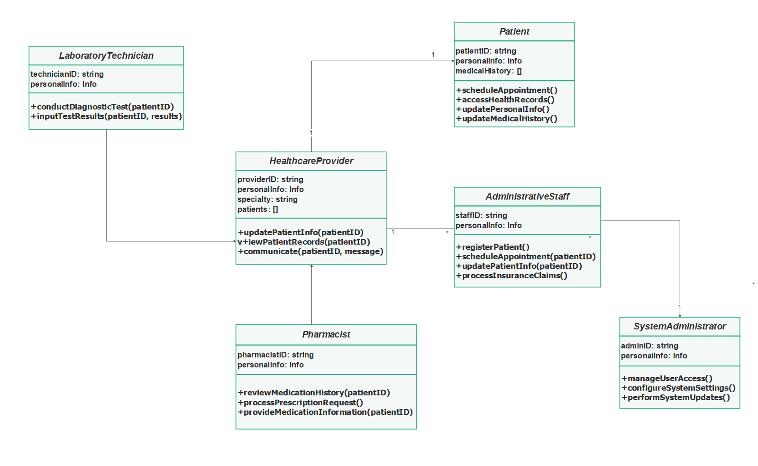

## 3.2 Dynamic model

### 3.2.1 Sequence diagram

Figure 3 sequence diagram for patient sign up

Figure 4 sequence diagram for patient login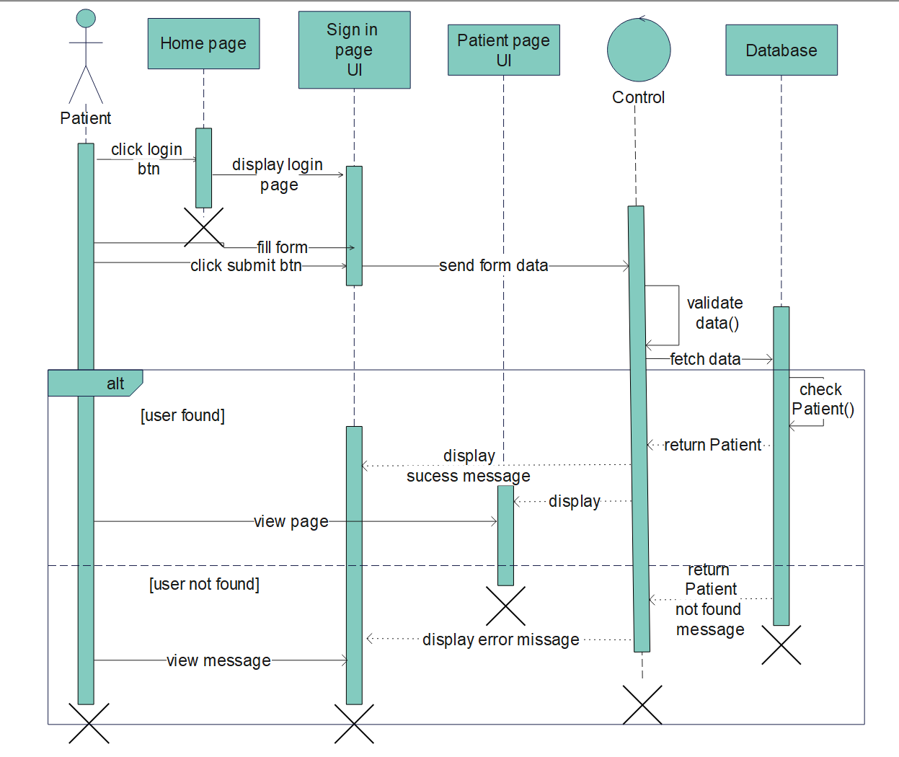

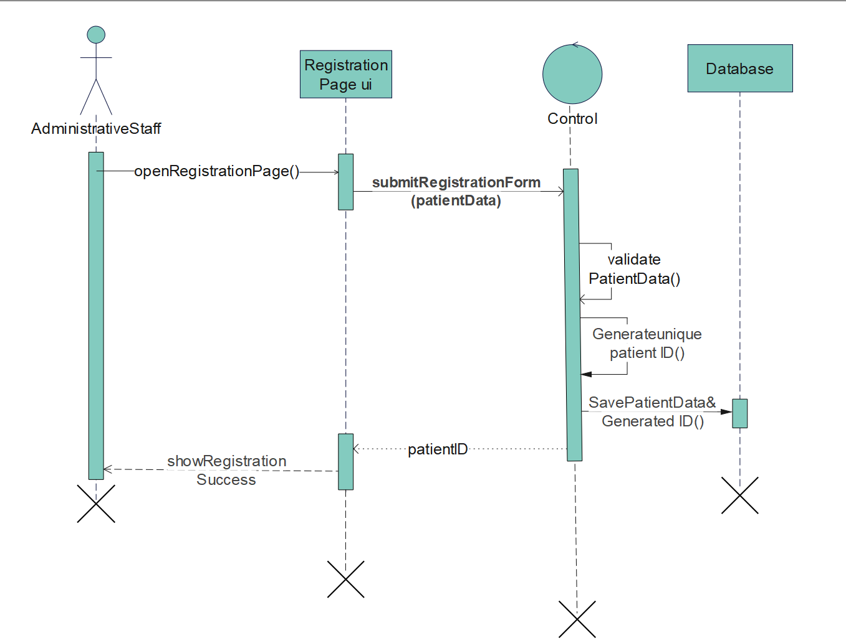

Figure 5 sequence diagram for Adminstrative staff registering patient

3.2.2 Activity diagram

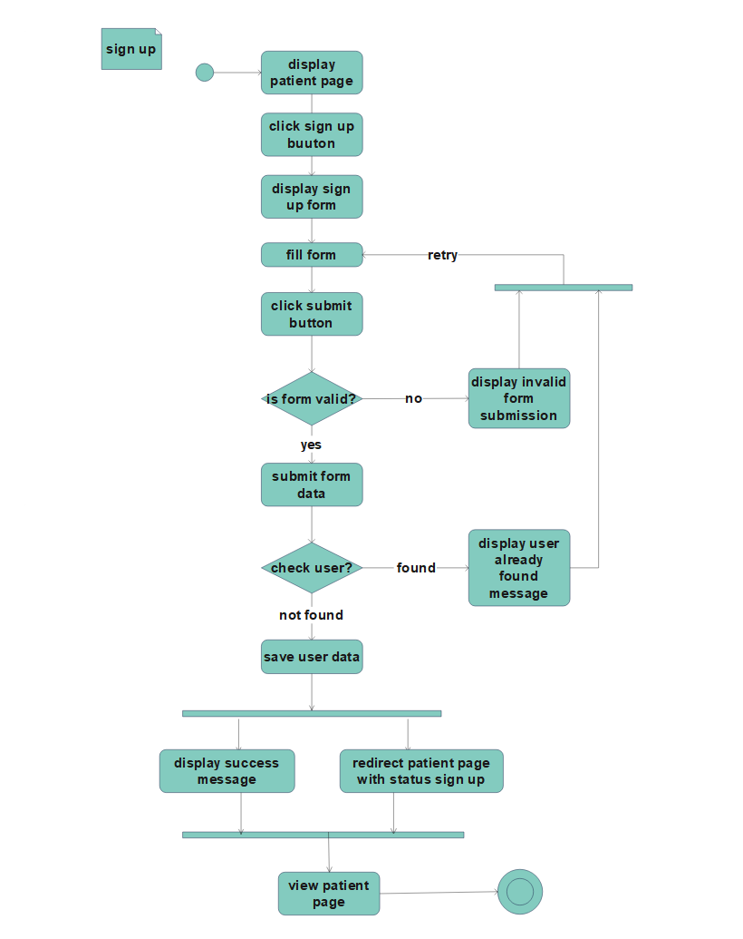

Figure 6 Activity diagram for patient sign up

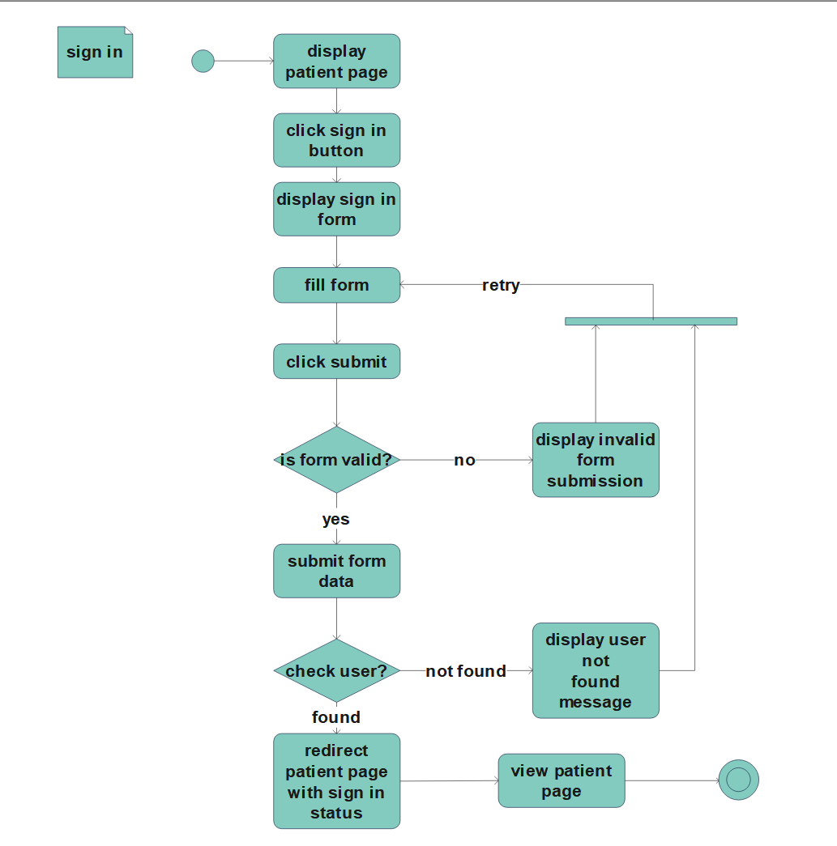

Figure 7 Activity diagram for patient login

Figure 8 Activity diagram for Adminstrative staff registering patient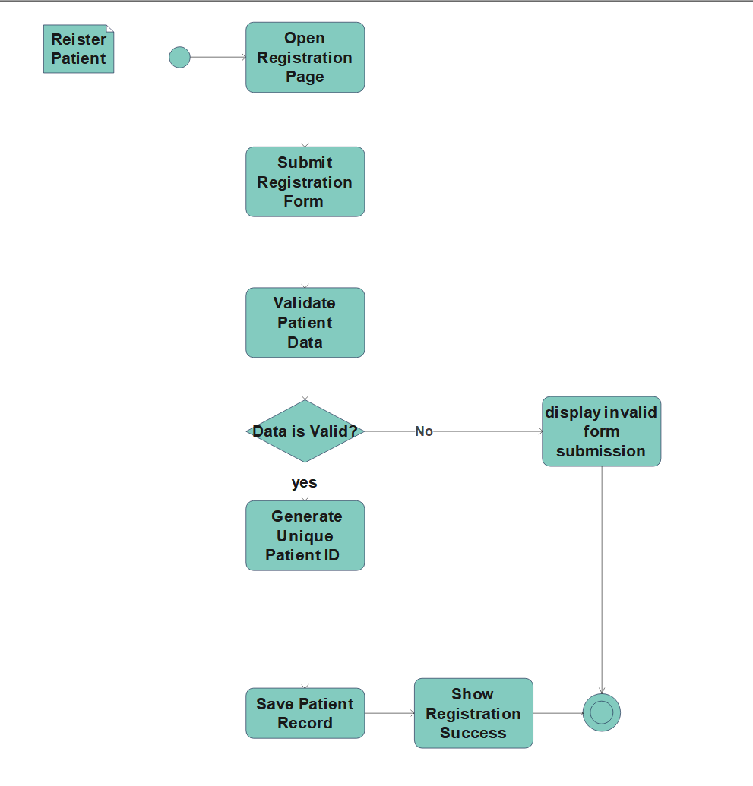

### 3.2.4 User interface

Figure 9 proposed User interface for the homepage of the patient tracking system

Figure 10 proposed User interface for the signup page of the patient tracking system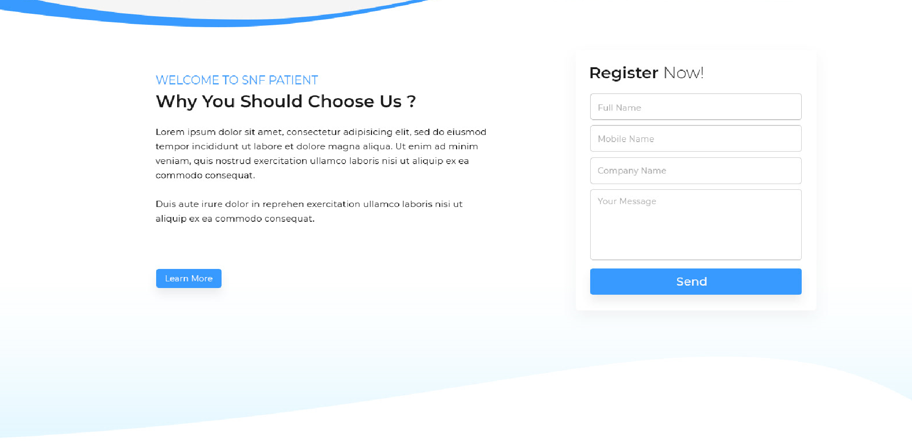

# **Chapter 4: System design**

## 4.1 Introduction

System design is the process of defining the architecture, components, modules, interfaces, and data for a software system to satisfy specified requirements. It involves creating a blueprint or plan that outlines how the patient tracking system will function, perform, and integrate with other systems.

A patient tracking system needs to have several key features, including the ability to record and update patient information, track medical appointments, manage healthcare provider schedules, generate reports, and provide a user-friendly interface for healthcare staff to interact with. Additionally, it should incorporate security measures to protect patient data and ensure reliable performance even during high-demand periods.

### 4.1.1 Purpose and goals of the system

Patient Tracking System: Goals and Purpose

Goals:

* **Intuitive User Interface:** Design a user-friendly interface for healthcare staff to efficiently track and manage patient information, appointments, and medical records.
* **Data Accuracy and Security:** Ensure secure storage and accurate management of patient data, including personal details, medical history, and treatment records.
* **Efficient Patient Management:** Facilitate streamlined patient tracking, including registration, scheduling, and tracking of patient progress throughout their healthcare journey.
* **Seamless Integration:** Enable seamless integration with other healthcare systems, such as electronic health records (EHRs), appointment scheduling systems, and billing systems.

The purpose of the Patient Tracking System is to develop a software system that provides healthcare professionals with an efficient and secure solution for tracking and managing patient information. It aims to simplify patient registration, ensure data accuracy and security, enable efficient patient management, and seamlessly integrate with other healthcare systems for a comprehensive patient tracking experience.

## 4.2 Current software architecture

The existing manual patient tracking system involves a simple workflow where healthcare professionals manage patient information and appointments manually. The process includes patient registration, appointment scheduling, and tracking patient progress. The system relies on manual communication and record-keeping methods.

## 4.3 Proposed software architecture

For the patient tracking system, we will adopt a Three-tier architecture. This architecture divides the system into three layers: the presentation layer, the application layer, and the data layer. The presentation layer handles the user interface, the application layer manages the business logic, and the data layer handles data storage and retrieval. This architecture offers modularity, scalability, and security, making it suitable for a patient tracking application.

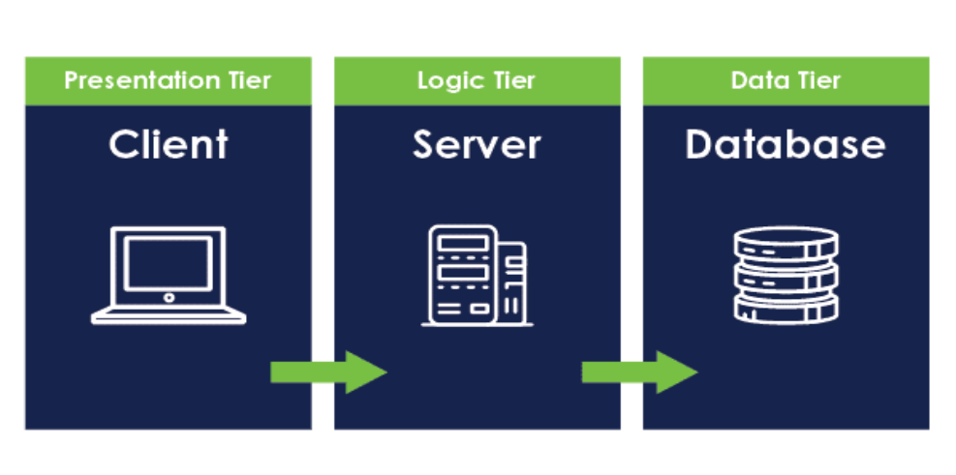

Figure 11 Proposed software architecture

### **4.3.1 Database Design**

## Database design is crucial for creating an efficient and organized structure to store and retrieve data in a software system. For a train ticketing system, the database design would involve defining the entities and their relationships

## Figure 12 Database design

## 

## 4.4 Deployment diagram

Database design is crucial for creating an efficient and organized structure to store and retrieve data in a software system. For a patient tracking system, the database design would involve defining the entities and their relationships, ensuring efficient storage and retrieval of patient information.

Figure 13 Deployment diagram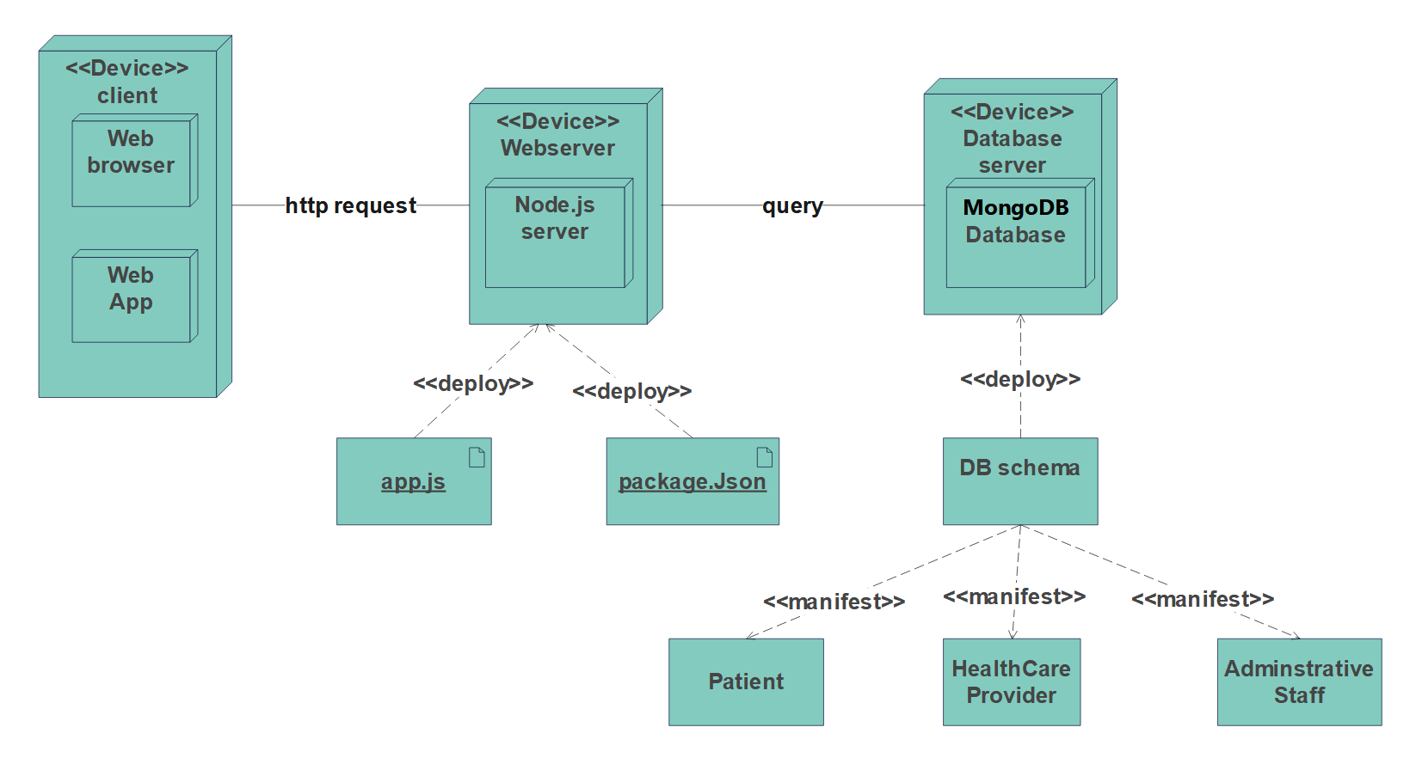

# References

[1]. "Patient Tracking System: A Comprehensive Guide" by Healthcare IT Solutions

[2]. "Designing an Efficient Patient Tracking System" by Journal of Healthcare Engineering

[3]. "Patient Tracking System Implementation Best Practices" by Health Catalyst

[4]. "Database Design for Healthcare Systems" by International Journal of Database Management Systems

[5]. "Privacy and Security Considerations in Patient Tracking Systems" by Healthcare Information and Management Systems Society (HIMSS)